1.Perform basic Image Handling and processing operations on the image. • Read an image in python and Convert an Image to Grayscale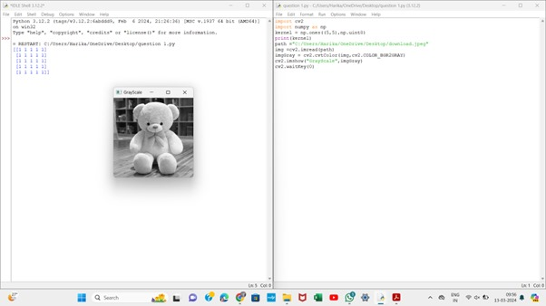

2. Perform basic Image Handling and processing operations on the image.• Read an image in python and Convert an Image to Blur using GaussianBlur.

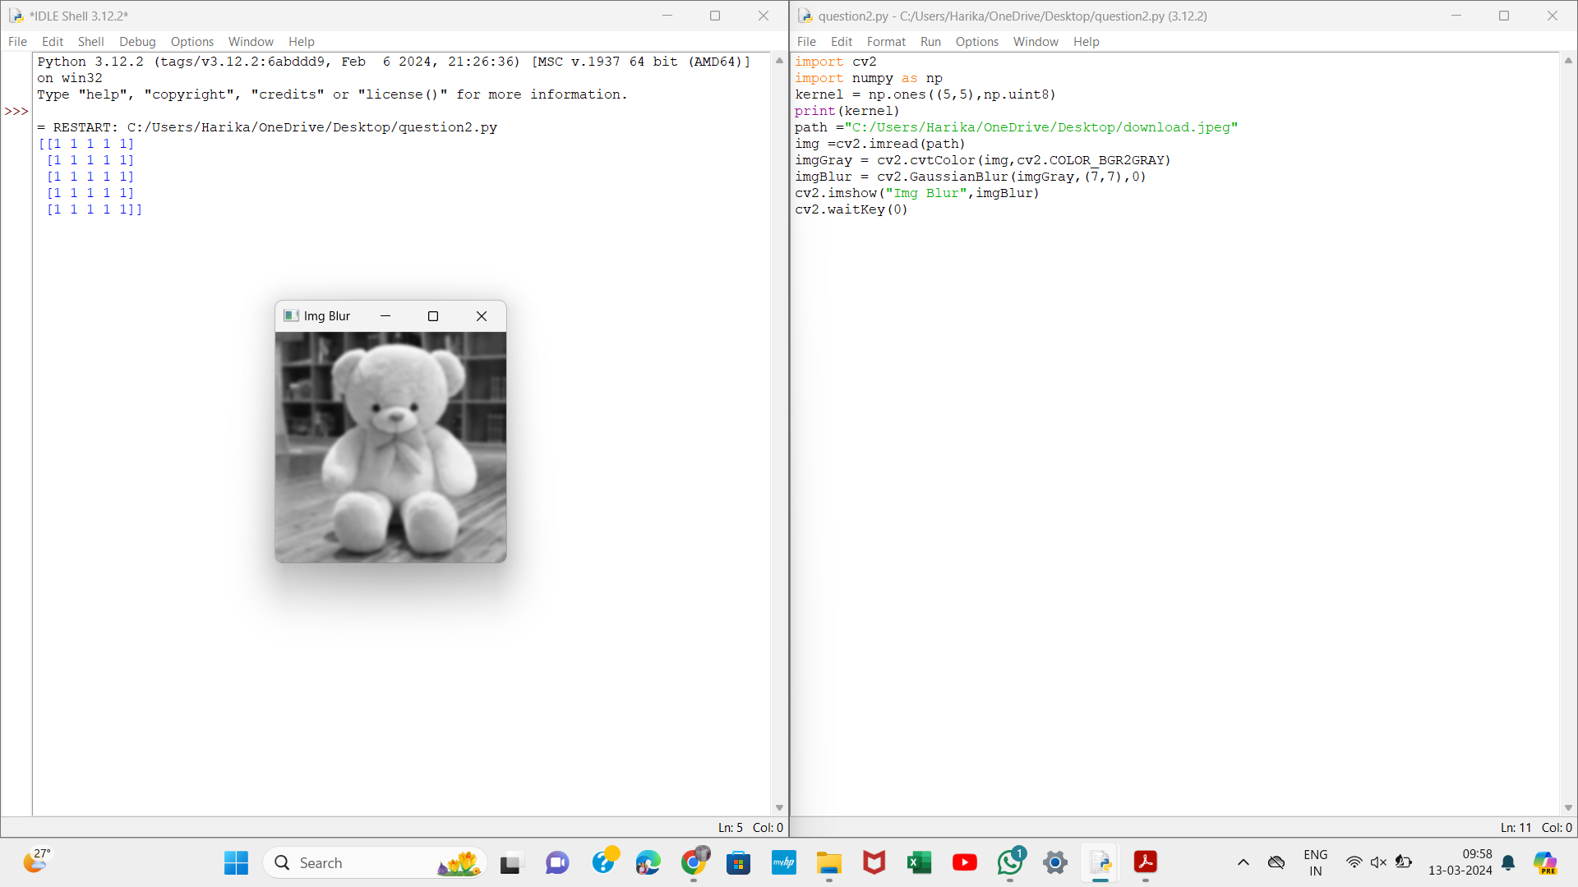

3. Perform basic Image Handling and processing operations on the image• Read an image in python and Convert an Image to show outline using Canny function

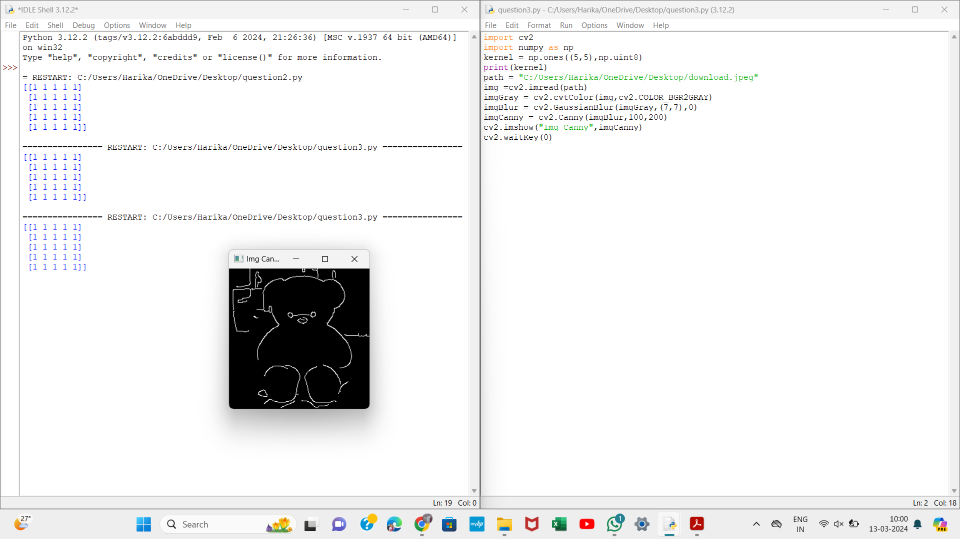

4. Perform basic Image Handling and processing operations on the image• Read an image in python and Dilate an Image using Dilate function

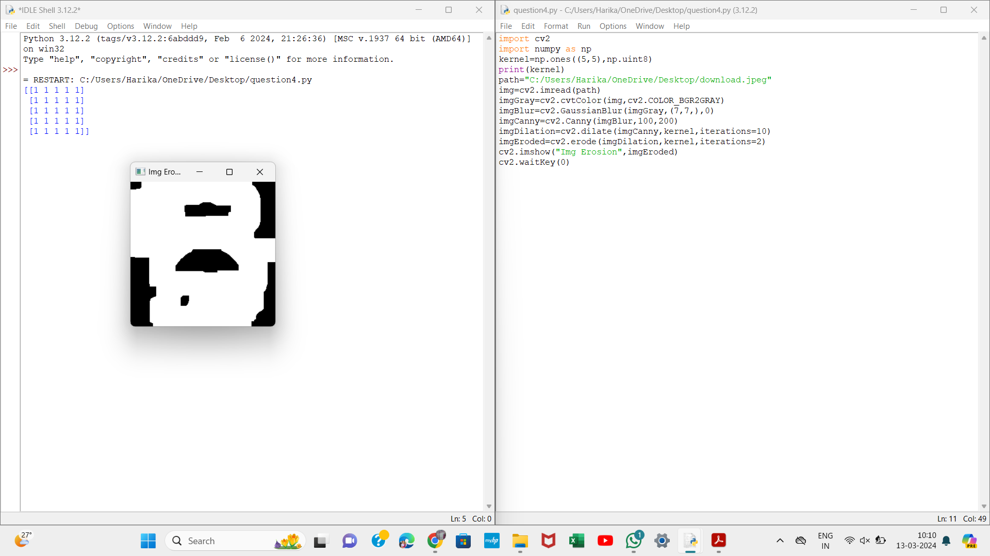

5. Perform basic Image Handling and processing operations on the image• Read an image in python and Erode an Image using erode function

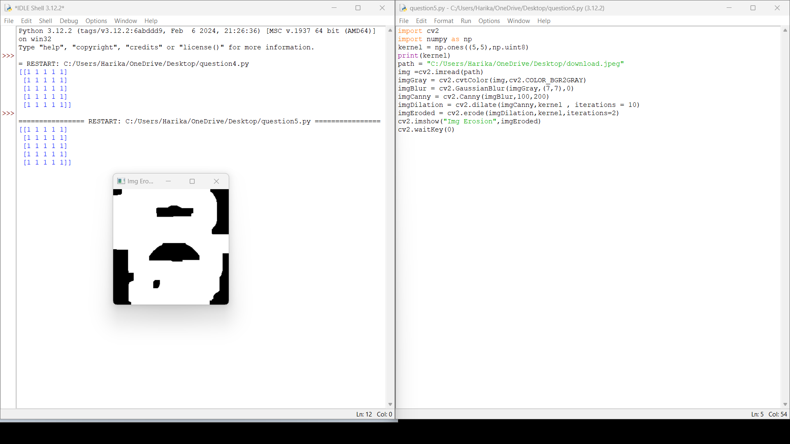

6. Perform basic video processing operations on the captured video• Read captured video in python and display the video, in slow motion and in fast motion.

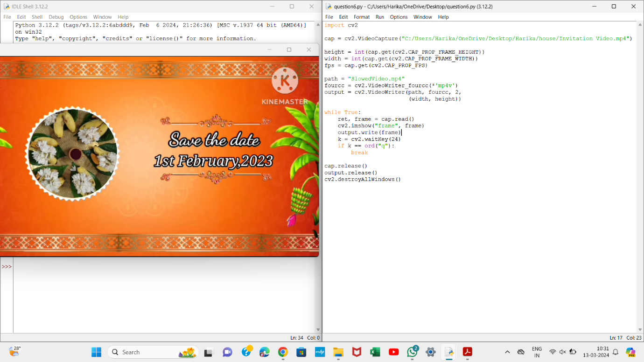

7. Capture video from web Camera and Display the video, in slow motion and in fast motion operations on the captured video

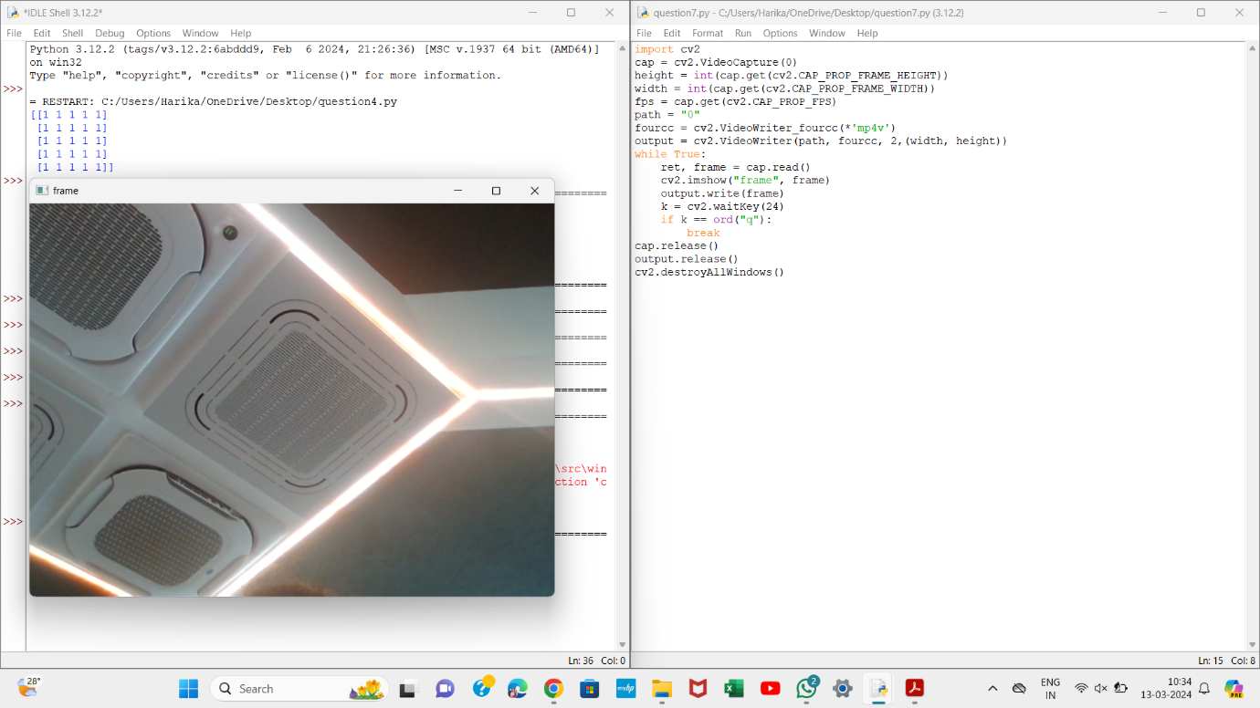

8. Scaling an image to its Bigger and Smaller sizes.

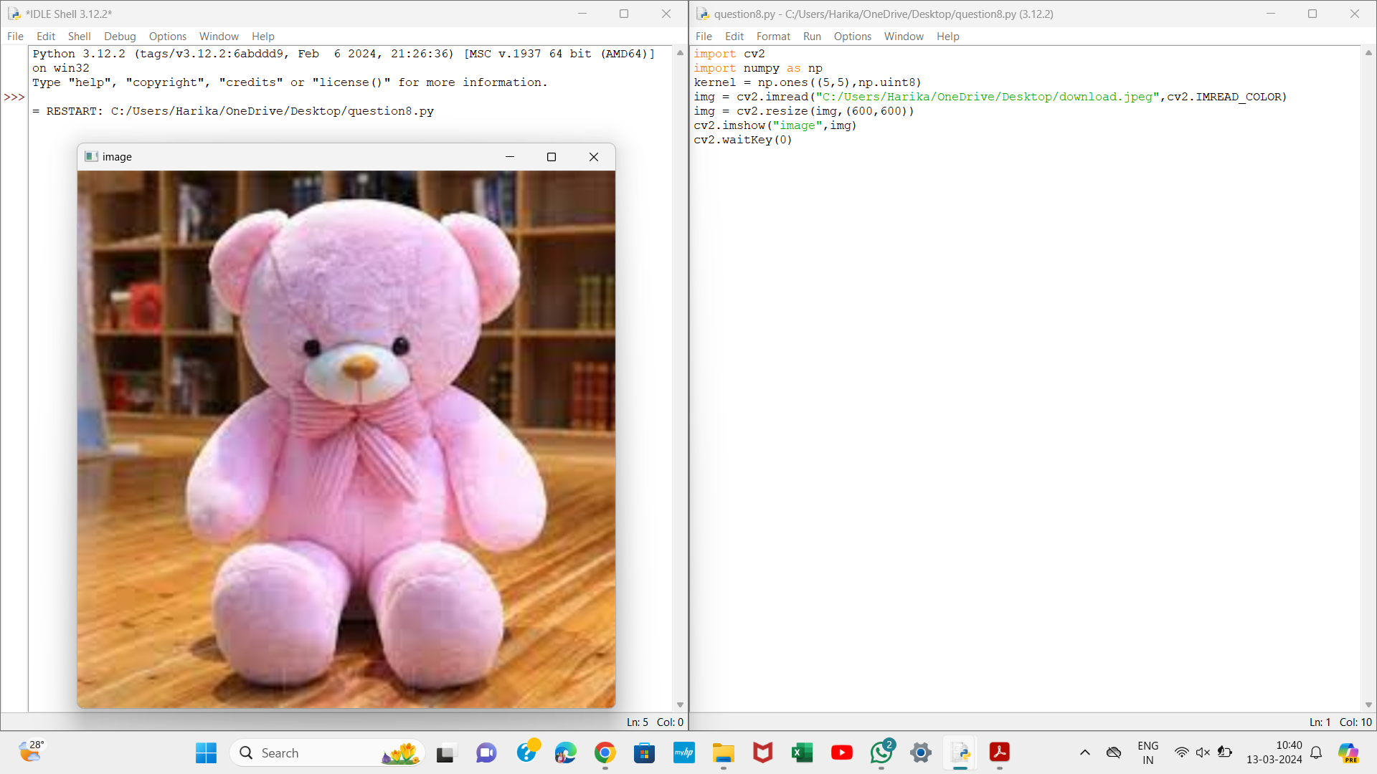

9.ROTATION 90 ALONG DEGREE:

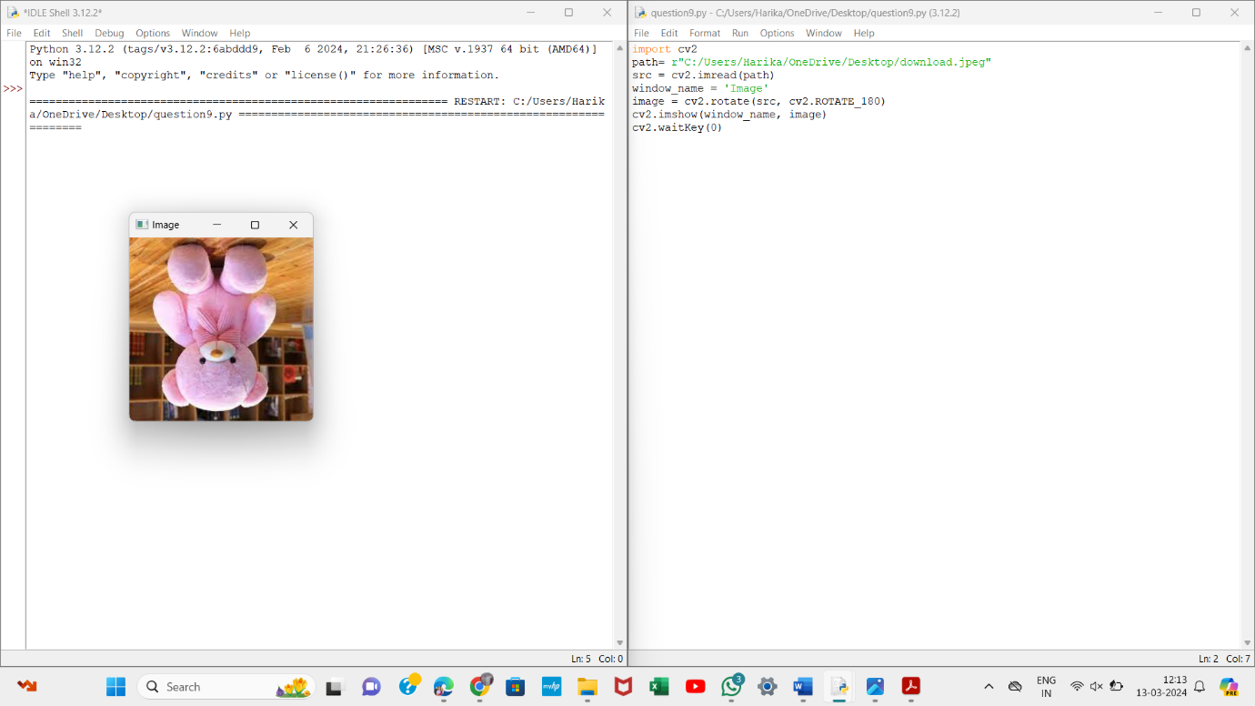

10.ROTATION ALONG 180 DEGREE

